**Lobster**

---Mike Yuan

The game I am going to create would probably be an RPG. Basically what the player has to do is to follow the storyline and explore the map at the same time, and eventually finish the game at the end. This process will not be very easy since there will be monsters and perhaps some other challenges on the way. The game will be named *“Lobster”*  since the main character the player will be controlling is a lobster.

There will be about 1 or more levels involved in this game depends on the time that I have. For the first level which is guaranteed the player will be spawned at the left top corner of the map. The goal is to explore the map and find the way out. The map also features lighting system which can make it harder to explore and be aware of the hidden monsters. The player will be able to pick up some key items to pass locked doors and weapons to defend themselves. Finally the player will be in a boss room for the final fight between the player and the boss. As soon as the player beats the boss, he will be able to unlock the door to a new level. If the player dies during the process, he has to start right from the beginning, so it is highly recommended to carefully manage the resource and stay alert in darkened 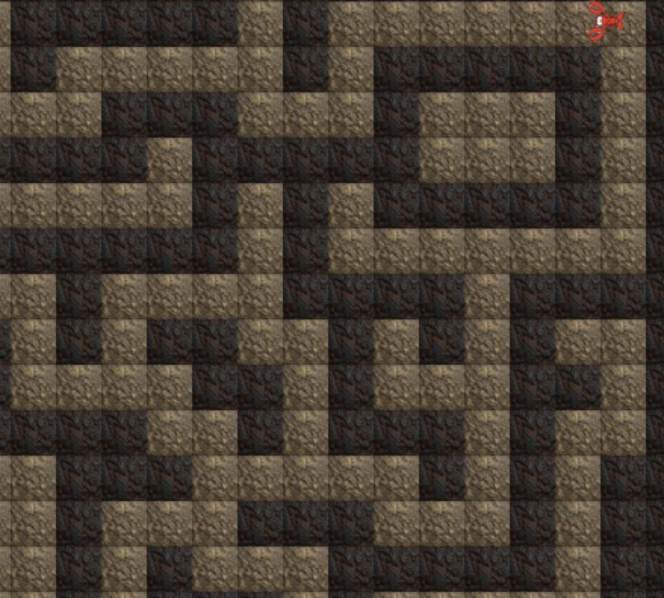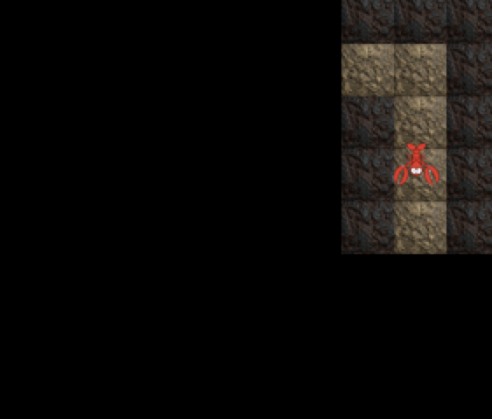area.

*(A quick shot of the map and the character)* *(Lighting system still under development)*

The main part of the game will probably be finished by early June.